1. Write a program to find entered number is even or odd

#include<stdio.h>

int main(){

    int n;

    printf("\nEnter the number to check even or odd:");

    scanf("%d",&n);

    if(n % 2 == 0)

    printf("\nThe number %d is Even.",n);

    else

    printf("\nThe number %d is Odd.",n);

    printf("\nSuyash Rusia Roll no.:58");

    return 0;

}

Output:

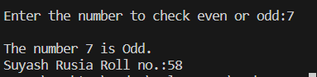

2. Write a program to find area of triangle

#include<stdio.h>

int main(){

    int b,h;

    float a;

    printf("\nEnter Base and Height of Triangle:");

    scanf("%d %d",&b,&h);

    a = ((b*h)/2);

    printf("\nThe area of Triangle is %f",a);

    printf("\nSuyash Rusia Roll no.:58");

    return 0;

}

Output:

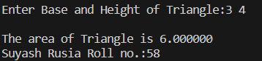

3. Write a program to find area of circle

#include<stdio.h>

int main(){

    int r;

    float a;

    printf("\nEnter Radius of Circle:");

    scanf("%d",&r);

    a = 3.14*(r*r);

    printf("\nThe area of Circle is %f",a);

    printf("\nSuyash Rusia Roll no.:58");

    return 0;

}

Output:

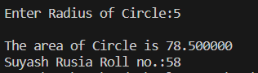

4. Write a program to find the largest number among three entered number

#include<stdio.h>

int main(){

    int a,b,c;

    printf("\nEnter Three Numbers:");

    scanf("%d %d %d",&a,&b,&c);

    if ((a>b) && (a>c))

    printf("\nThe %d is Largest of all.",a);

    else if ((b>a) && (b>c))

    printf("\nThe %d is Largest of all.",b);

    else

    printf("\nThe %d is Largest of all.",c);

    printf("\nSuyash Rusia Roll no.:58");

    return 0;

}

Output:

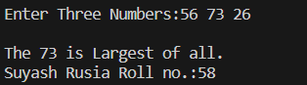

5. Write a program to find the smallest number among three entered number

#include<stdio.h>

int main(){

    int a,b,c;

    printf("\nEnter Three Numbers:");

    scanf("%d %d %d",&a,&b,&c);

    if ((a<b) && (a<c))

    printf("\nThe %d is Smallest of all.",a);

    else if ((b<a) && (b<c))

    printf("\nThe %d is Smallest of all.",b);

    else

    printf("\nThe %d is Smallest of all.",c);

    printf("\nSuyash Rusia Roll no.:58");

    return 0;

}

Output:

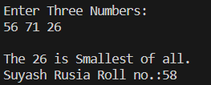

6. Write a program to interchange the value of two variable using third variable

#include<stdio.h>

int main(){

    int a,b,c;

    printf("\nEnter Two Numbers:");

    scanf("%d %d",&a,&b);

    printf("\nThe value of a is %d and b is %d",a,b);

    c = a;

    a = b;

    b = c;

    printf("\nThe value of a is %d and b is %d",a,b);

    printf("\nSuyash Rusia Roll no.:58");

    return 0;

}

Output:

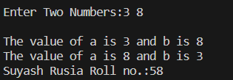

7. Write a program to convert the temperature entered in Celsius to Fahrenheit ( (temp *9/5)+32)

#include<stdio.h>

int main(){

    int c;

    float f = 0;

    printf("\nEnter Temprature in Celcius:");

    scanf("%d",&c);

    f = ( (c *1.8)+32);

    printf("\nTemprature in Fahrenheit is %f.",f);

    printf("\nSuyash Rusia Roll no.:58");

    return 0;

}

Output:

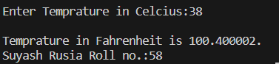

8. Write a program to interchange the value of two variable without using third variable

#include<stdio.h>

int main(){

    int a,b;

    printf("\nEnter Two Numbers:");

    scanf("%d %d",&a,&b);

    printf("\nThe value of a is %d and b is %d",a,b);

    a = a + b;

    b = a - b;

    a = a - b;

    printf("\nThe value of a is %d and b is %d",a,b);

    printf("\nSuyash Rusia Roll no.:58");

    return 0;

}

Output:

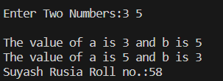

9. Write a program to find series of even and odd numbers till the Nth element

#include<stdio.h>

int main(){

    int i,n;

    printf("\nEnter the number for serise of Odd ans Even:");

    scanf("%d",&n);

    for(i=1;i<=n;i++){

        if(i%2 == 0){

            printf("\n%d is Even Number.",i);

        }

        else{

            printf("\n%d is Odd Number.",i);

        }

    }

    printf("\nSuyash Rusia Roll no.:58");

    return 0;

}

Output:

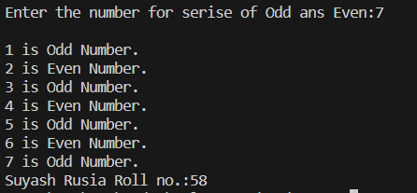

10. Write a program to find factorial of entered number

#include <stdio.h>

int main(){

    int no, i, fact = 1;

    printf("Enter Number for Factorial: ");

    scanf("%d", &no);

    for(i = 1; i <= no; i++){

        fact = fact * i;

    }

    printf("Factorial of %d is %d", no, fact);

    printf("\nSuyash Rusia Roll no.:58");

    return 0;

}

Output:



11. Write a program to find series of factorial number till the Nth element

#include <stdio.h>

int main(){

    int no, i, fact, j;

    printf("Enter Number for Factorial till Nth element: ");

    scanf("%d", &no);

    for(i = 0; i <= no; i++){

        fact = 1;

        for(j = 1; j <= i; j++){

            fact = fact * j;

        }

    printf("%d! = %d\n", i, fact);

    }

    printf("\nSuyash Rusia Roll no.:58");

    return 0;

}

Output:

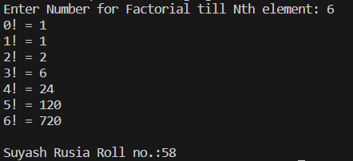

12. Write a program to find entered number is prime or not

#include <stdio.h>

int main()

{

    int no, i;

    printf("Enter Number to check prime or not: ");

    scanf("%d", &no);

    for(i = 2; i < no; i++){

        if (no % i == 0){

            printf("%d is Composite Number", no);

            return;

        }

    }

    printf("%d is Prime Number", no);

    printf("\nSuyash Rusia Roll no.:58");

return 0;

}

Output:

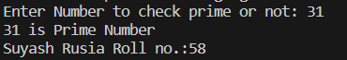

13. Write a program to find series of prime number till the Nth element

#include <stdio.h>

int main() {

    int no, i, j, flag;

    printf("Enter Number: ");

    scanf("%d", &no);

    printf("List of Prime Numbers:\n");

    i = 2;

    while (i <= no) {

        flag = 0;

        j = 2;

        while (j < i) {

            if (i != 2 && i % j == 0) {

                flag++;

                break;

            }

            j++;

        }

        if (flag == 0)

            printf("%d\n", i);

        i++;

    }

    printf("\nSuyash Rusia Roll no.:58");

    return 0;

}

Output:

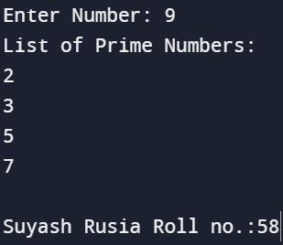

14. Write a program to find entered number is Armstrong or not

#include <stdio.h>

int main(){

    int no, tmp, rem, res = 0;

    printf("Enter Number: ");

    scanf("%d", &no);

    tmp = no;

    while(tmp != 0){

        rem = tmp % 10;

        res = res + (rem * rem * rem);

        tmp = tmp / 10;

    }

    if (res == no)

        printf("%d is Amstrong Number", no);

    else

        printf("%d is Not Amstrong Number", no);

    printf("\nSuyash Rusia Roll no.:58");

    return 0;

}

Output:

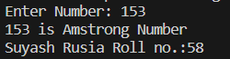

15. Write a program to find series of Armstrong number till the Nth element

#include <stdio.h>

int main() {

    int n,i,temp,sum,count,num,rem,res;

    printf("Enter a number for Armstrong Serise: ");

    scanf("%d", &n);

    printf("Armstrong numbers up to %d:\n", n);

    for ( i = 1; i <= n; i++) {

         temp = i;

         sum = 0;

         count = 0;

         num = i;

        while (num != 0) {

            num /= 10;

            count++;

        }

        num = temp;

        while (num != 0) {

             rem = num % 10;

             res = rem * rem * rem;

            sum += res;

            num /= 10;

        }

        if (sum == temp) {

            printf("%d\n", i);

        }

    }

    printf("\nSuyash Rusia Roll no.:58");

    return 0;

}

Output:

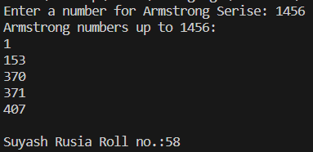

16. Write a program to find sum of digit of entered number

#include <stdio.h>

int main(){

    int no, res = 0, rem;

    printf("Enter Number: ");

    scanf("%d", &no);

    while(no != 0){

        rem = no % 10;

        res = res + rem;

        no = no / 10;

    }

    printf("Sum of Digits: %d", res);

    printf("\nSuyash Rusia Roll no.:58");

    return 0;

}

Output:

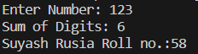

17. Write a program to find reveres of entered number

#include <stdio.h>

int main(){

    int no, rev = 0, rem;

    printf("Enter Number: ");

    scanf("%d", &no);

    while(no != 0){

        rem = no % 10;

        rev = rev * 10 + rem;

        no = no / 10;

    }

    printf("Reverse: %d", rev);

    printf("\nSuyash Rusia Roll no.:58");

    return 0;

}

Output:

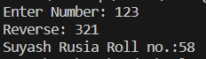

18. C Program to print Fibonacci series in a given range

#include <stdio.h>

int main(){

    int i, n1 = 0, n2 = 1, n3, no;

    printf("Enter Number: ");

    scanf("%d", &no);

    for(i = 0; i < no; i++){

        printf("%d\t", n1);

        n3 = n1 + n2;

        n1 = n2;

        n2 = n3;

    }

    printf("\nSuyash Rusia Roll no.:58");

    return 0;

}

Output:

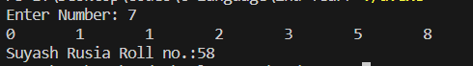

19. C Program to check if given number is palindrome or not

#include <stdio.h>

int main(){

    int no, rev = 0, rem, tmp;

    printf("Enter Number to check palindrome: ");

    scanf("%d", &no);

    tmp = no;

    while(no != 0){

        rem = no % 10;

        rev = rev * 10 + rem;

        no = no / 10;

    }

    if(tmp == rev)

        printf("%d is Palindrome", tmp);

    else

        printf("%d is Not Palindrome", tmp);

    printf("\nSuyash Rusia Roll no.:58");

    return 0;

}

Output:

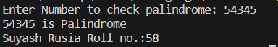

20. Write a program to find series of palindrome till the Nth element

#include<stdio.h>

int fun(int n){

    int temp,rev = 0,rem;

    temp = n;

    while(n != 0){

        rem = n % 10;

        rev = rev * 10 + rem;

        n = n / 10;

    }if(temp == rev)

     printf("%d is Palindrome.\n",temp);

    return 0;

}

int main(){

    int i,n;

    printf("Enter the number for palindrome serise:");

    scanf("%d",&n);

    for(i=1;i<=n;i++){

        fun(i);

    }

    printf("\nSuyash Rusia Roll no.:58");

    return 0;

}

Output:

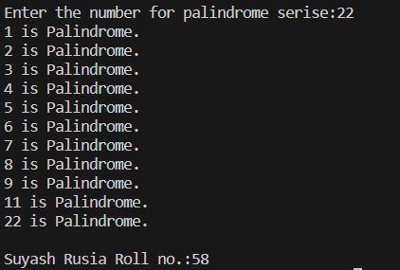

21. Write A C Program To Print Multiplication Table

#include <stdio.h>

int main(){

    int no, i;

    printf("Enter Number: ");

    scanf("%d", &no);

    for(i = 1; i <= 10; i++){

        printf("%d x %d = %d\n", no, i, no*i);

    }

    printf("\nSuyash Rusia Roll no.:58");

    return 0;

}

Output:

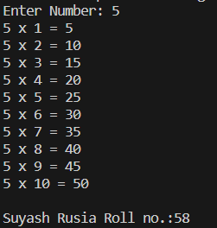

22. C Program to Check whether an Alphabet is Vowel or Consonant

#include <stdio.h>

#include <ctype.h>

int main(){

    char ch, c;

    printf("Enter Alphabet: ");

    scanf("%c", &ch);

    if(isalpha(ch)){

        c = tolower(ch);

        if(c == 'a' || c == 'e' || c == 'i' || c == 'o' || c == 'u')

            printf("%c is a Vowel", ch);

        else

            printf("%c is a Consonant", ch);

    }

    else

        printf("%c is not an Alphabet", ch);

    printf("\nSuyash Rusia Roll no.:58");

        return 0;

}

Output:

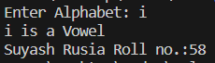

23. Write a program to find GCD (Greatest common divisor)

#include<stdio.h>

int main(){

    int a,b,i,g;

    printf("Enter the Numbers for GDC:");

    scanf("%d %d",&a,&b);

    for(i = 1; i<= (a>b?a:b); i++){

        if(a % i == 0 && b % i == 0)

        g = i;

    }

    printf("Greatest Common Divisor : %d",g);

    printf("\nSuyash Rusia Roll no.:58");

    return 0;

}

Output:

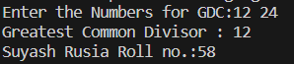

24. Write a program to check the entered year is leap year or not

#include <stdio.h>

int main(){

    int yr;

    printf("Enter to check leap Year: ");

    scanf("%d", &yr);

    if (yr % 400 == 0)

        printf("%d is Leap Year", yr);

    else if (yr % 100 == 0)

        printf("%d is Not Leap Year", yr);

    else if (yr % 4 == 0)

        printf("%d is Leap Year", yr);

    else

        printf("%d is Not Leap Year", yr);

    printf("\nSuyash Rusia Roll no.:58");

    return 0;

}

Output:

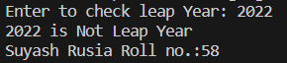

25. C Program to find the Sum of First n Natural numbers

#include <stdio.h>

int main(){

    int no, ans = 0;

    printf("Enter Number to get sum till: ");

    scanf("%d", &no);

    while (no != 0){

        ans += no;

        no--;

    }

    printf("Sum = %d", ans);

    printf("\nSuyash Rusia Roll no.:58");

    return 0;

}

Output:

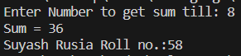

26. Write a program to print the pyramid of stars

#include <stdio.h>

int main() {

    int height;

    printf("Enter the number of rows:");

    scanf("%d", &height);

    for (int i = 1; i <= height; i++) {

        for (int j = 1; j <= i; j++) {

            if (j == 1 || j == i || i == height) {

                printf("*");

            } else {

                printf(" ");

            }

        }

        printf("\n");

    }

    printf("\nSuyash Rusia Roll no.:58");

    return 0;

}

Output:

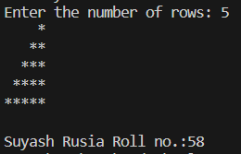

#include <stdio.h>

int main() {

    int height;

    printf("Enter the number of rows:");

    scanf("%d", &height);

    for (int i = 1; i <= height; i++) {

        for (int j = 1; j <= i; j++) {

            if (j == 1 || j == i || i == height) {

                printf("*");

            } else {

                printf(" ");

            }

        }

        printf("\n");

    }

    printf("\nSuyash Rusia Roll no.:58");

    return 0;

}

Output:

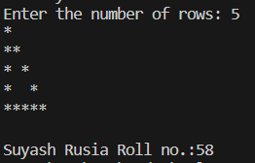

27. Write a program to print the following number pattern

#include <stdio.h>

int main(){

    int h, i, j;

    printf("Enter Height: ");

    scanf("%d", &h);

    for (i = h; i >= 0; i--)

    {

        for (j = 1; j <= i; j++)

        {

            printf("%d", j);

        }

        printf("\n");

    }

    printf("\nSuyash Rusia Roll no.:58");

    return 0;

}

Output:

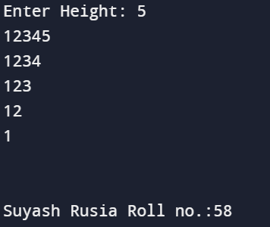

#include <stdio.h>

int main()

{

    int h, i, j;

    printf("Enter Height: ");

    scanf("%d", &h);

    for (i = 1; i <= h; i++)

    {

        for (j = i; j <= h; j++)

        {

            printf("%d", j);

        }

        printf("\n");

    }

    printf("\nSuyash Rusia Roll no.:58");

    return 0;

}

Output:

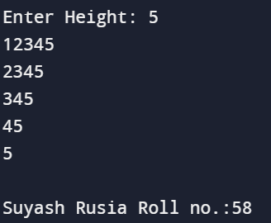

28. Write a program to find Net salary of employee.Basic salary entered by user.HRA is 40% basic, Da is 90% of basic, TA is 20 % of basic, PF is 25 % of basic.

#include <stdio.h>

int main() {

    double salary, net, hra, da, ta, pf;

    printf("Enter Basic Salary: ");

    scanf("%lf", &salary);

    hra = 0.4 * salary;

    da = 0.9 * salary;

    ta = 0.2 * salary;

    pf = 0.25 * salary;

    net = (salary + hra + da + ta - pf);

    printf("Net Salary: %.2lf\n", net);

    printf("\nSuyash Rusia Roll no.:58");

    return 0;

}

Output:

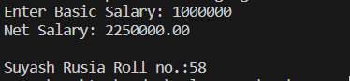

29. Write a menu driven program for 1. Check no is Even or odd number. 2.Check no is Prim or not 3. Check no is palindrome or not

#include<stdio.h>

int main()  {

    int n,no,i, rev = 0, rem, tmp;

    printf("Enter accordingly:\n1 to Check no is Even or odd number\n2 to Check no is Prime or not\n3 to Check no is palindrome or not\nYour choice:");

    scanf("%d",&n);

    switch (n)

    {

    case 1:

        printf("\nEnter the number to check even or odd:");

        scanf("%d",&no);

        if(no % 2 == 0)

        printf("\nThe number %d is Even.",no);

        else

        printf("\nThe number %d is Odd.",no);

        break;

    case 2:

        printf("Enter Number to check prime or not: ");

        scanf("%d", &no);

        for(i = 2; i < no; i++){

            if (no % i == 0){

            printf("%d is Not Prime Number", no);

            return;

          }

        }

        printf("%d is Prime Number", no);

        break;

    case 3:

        printf("Enter Number to check palindrome: ");

        scanf("%d", &no);

        tmp = no;

        while(no != 0){

            rem = no % 10;

            rev = rev * 10 + rem;

            no = no / 10;

        }

        if(tmp == rev)

            printf("%d is Palindrome", tmp);

        else

            printf("%d is Not Palindrome", tmp);

        break;

    default:

        printf("Enter valid Choice.");

        break;

    }

printf("\nSuyash Rusia Roll no.:58");

return 0;

}

Output:

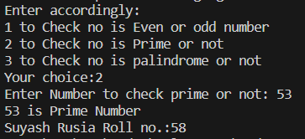

30. Write a menu driven program for 1. Print Pyramid of stars * 2. Right triangle star pattern 3. Left or mirrored triangle star pattern 4. Hollow right triangle star pattern

#include <stdio.h>

void printPyramid(int n) {

    for (int i = 1; i <= n; i++) {

        for (int j = 1; j <= n - i; j++) {

            printf(" ");

        }

        for (int k = 1; k <= 2 * i - 1; k++) {

            printf("*");

        }

        printf("\n");

    }

}

void printRightTriangle(int n) {

    for (int i = 1; i <= n; i++) {

        for (int j = 1; j <= i; j++) {

            printf("*");

        }

        printf("\n");

    }

}

void printMirroredTriangle(int n) {

    for (int i = 1; i <= n; i++) {

        for (int j = 1; j <= n - i; j++) {

            printf(" ");

        }

        for (int k = 1; k <= i; k++) {

            printf("*");

        }

        printf("\n");

    }

}

void printHollowRightTriangle(int n) {

    for (int i = 1; i <= n; i++) {

        if (i == 1 || i == n) {

            for (int j = 1; j <= i; j++) {

                printf("*");

            }

        } else {

            printf("*");

            for (int j = 1; j <= i - 2; j++) {

                printf(" ");

            }

            printf("*");

        }

        printf("\n");

    }

}

int main() {

    int choice, n;

        printf("Choose a star pattern:\n");

        printf("1. Print Pyramid of stars\n");

        printf("2. Right triangle star pattern\n");

        printf("3. Left or mirrored triangle star pattern\n");

        printf("4. Hollow right triangle star pattern\n");

        printf("5. Exit\n");

        printf("Enter your choice: ");

        scanf("%d", &choice);

        printf("Enter the number of rows: ");

        scanf("%d", &n);

        switch (choice) {

            case 1:

                printPyramid(n);

                break;

            case 2:

                printRightTriangle(n);

                break;

            case 3:

                printMirroredTriangle(n);

                break;

            case 4:

                printHollowRightTriangle(n);

                break;

            case 5:

                break;

            default:

                printf("Invalid choice! Please enter a valid option.\n");

                break;

        }

    printf("\nSuyash Rusia Roll no.:58");

    return 0;

}

Output:

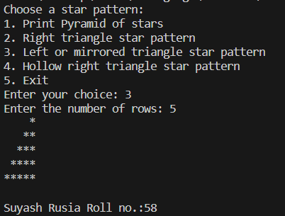

31.Write C program for to sort the array elements using bubble sort

#include <stdio.h>

void bubble_sort(int arr[], int n) {

  int i, j;

  for (i = 0; i < n - 1; i++) {

    for (j = 0; j < n - i - 1; j++) {

      if (arr[j] > arr[j + 1]) {

        int temp = arr[j];

        arr[j] = arr[j + 1];

        arr[j + 1] = temp;

      }

    }

  }

}

int main() {

  int arr[] = {54, 24, 75, 30, 12, 61, 72};

  int n = sizeof(arr) / sizeof(arr[0]);

  bubble_sort(arr, n);

  printf("Sorted array: ");

  for (int i = 0; i < n; i++) {

    printf("%d ", arr[i]);

  }

  printf("\nSuyash Rusia Roll No.:58");

  return 0;

}

Output:



32. Write C program for to sort the array elements using selection sort

#include <stdio.h>

void selection(int arr[], int n)  {

    int i, j, small;

    for (i = 0; i < n-1; i++){

        small = i;

        for (j = i+1; j < n; j++)

        if (arr[j] < arr[small])

            small = j;

    int temp = arr[small];

    arr[small] = arr[i];

    arr[i] = temp;

    }

}

void printArr(int a[], int n) {

    int i;

    for (i = 0; i < n; i++)

        printf("%d ", a[i]);

}

int main()  {

    int a[] = {54, 24, 75, 30, 12, 61, 72};

    int n = sizeof(a) / sizeof(a[0]);

    printf("Before sorting array elements are - \n");

    printArr(a, n);

    selection(a, n);

    printf("\nAfter sorting array elements are - \n");

    printArr(a, n);

    printf("\nSuyash Rusia Roll No.:58");

    return 0;

}

Output:

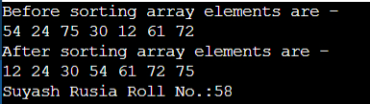

33. Write C program for to sort the array elements using insertion sort

#include <stdio.h>

void insert(int a[], int n){

    int i, j, temp;

    for (i = 1; i < n; i++) {

        temp = a[i];

        j = i - 1;

        while(j>=0 && temp <= a[j]){

            a[j+1] = a[j];

            j = j-1;

        }

        a[j+1] = temp;

    }

}

void printArr(int a[], int n) {

    int i;

    for (i = 0; i < n; i++)

        printf("%d ", a[i]);

}

int main()  {

    int a[] = {54, 24, 75, 30, 12, 61, 72};

    int n = sizeof(a) / sizeof(a[0]);

    printf("Before sorting array elements are - \n");

    printArr(a, n);

    insert(a, n);

    printf("\nAfter sorting array elements are - \n");

    printArr(a, n);

    printf("\nSuyash Rusia Roll No.:58");

    return 0;

}

Output:

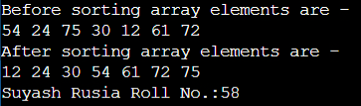

34. Write C program to find the largest element in the given array

#include <stdio.h>

#define MAX 5

int main()

{

    int record[MAX], i, greatest;

    printf("Enter 5 Elements:\n");

    for(i = 0; i < MAX; i++)

    {

        scanf("%d", &record[i]);

        if (i == 0)

            greatest = record[i];

        if (greatest < record[i])

            greatest = record[i];

    }

    printf("%d is the largest element\n", greatest);

    printf("\nSuyash Rusia Roll No.:58");

    return 0;

}

Output:

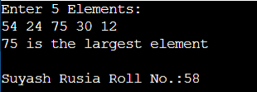

35. Write C program to find the smallest element in the given array

#include <stdio.h>

#define MAX 5

int main()

{

    int record[MAX], i, smallest;

    printf("Enter 5 Elements:\n");

    for(i = 0; i < MAX; i++)

    {

        scanf("%d", &record[i]);

        if (i == 0)

            smallest = record[i];

        if (smallest > record[i])

            smallest = record[i];

    }

    printf("%d is the smallest element\n", smallest);

    printf("\nSuyash Rusia Roll No.:58");

    return 0;

}

Output:

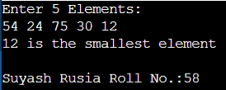

36. Write C program to find the sum of all elements given in array

#include <stdio.h>

#define MAX 5

int main()

{

    int record[MAX], i, sum = 0;

    printf("Enter 5 Elements:\n");

    for(i = 0; i < MAX; i++)

    {

        scanf("%d", &record[i]);

        sum += record[i];

    }

    printf("%d is the sum of all elements\n", sum);

    printf("\nSuyash Rusia Roll No.:58");

    return 0;

}

Output:

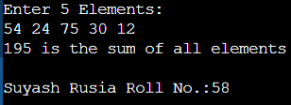

37. Write C program to find number of elements are prime in given array

#include <stdio.h>

#define MAX 5

int chk_prime(int no)

{

    int i;

    for(i = 2; i < no; i++)

    {

        if (no % i == 0)

            return -1;

    }

    return 0;

}

int main()

{

    int record[MAX], i, prime = 0;

    printf("Enter 5 Elements:\n");

    for(i = 0; i < MAX; i++)

    {

        scanf("%d", &record[i]);

        if(chk_prime(record[i]) == 0)

            prime++;

    }

    printf("%d elements are prime\n", prime);

    printf("\nSuyash Rusia Roll No.:58");

    return 0;

}

Output:

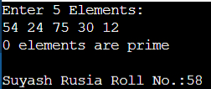

38. Write C program to find number of elements are even and odd in the given array

#include <stdio.h>

#define MAX 10

int even_odd(int no)

{

    if (no % 2 == 0)

        return 0;

    return 1;

}

int main()

{

    int record[MAX], i, even = 0, odd = 0;

    printf("Enter 10 Elements:\n");

    for(i = 0; i < MAX; i++)

    {

        scanf("%d", &record[i]);

        if(even_odd(record[i]) == 0)

            even++;

        else if(even_odd(record[i]) == 1)

            odd++;

    }

    printf("Odd : %d \t Even : %d\n", odd, even);

    printf("\nSuyash Rusia Roll No.:58");

    return 0;

}

Output:

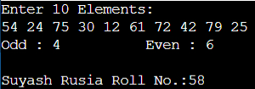

39. Write C program to find number of elements are positive, negative and zero in the given array

#include <stdio.h>

#define MAX 5

int sign(int no)

{

    if (no > 0)

        return 1;

    else if (no < 0 )

        return -1;

    return 0;

}

int main()

{

    int record[MAX], i, positive = 0, negative = 0, zero = 0;

    printf("Enter 5 Elements:\n");

    for(i = 0; i < MAX; i++)

    {

        scanf("%d", &record[i]);

        if(sign(record[i]) == 0)

            zero++;

        else if(sign(record[i]) == 1)

            positive++;

        else if(sign(record[i]) == -1)

            negative++;

    }

    printf("Positive : %d \t Negative : %d\t Zero : %d\n", positive, negative, zero);

    printf("\nSuyash Rusia Roll No.:58");

    return 0;

}

Output:

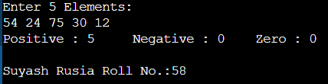

40. Write C program to find number of elements are palindrome in the given array

#include <stdio.h>

#define MAX 10

int palindrome(int no)

{

    int rev = 0, rem, tmp;

    tmp = no;

    while(no != 0)

    {

        rem = no % 10;

        rev = rev * 10 + rem;

        no = no / 10;

    }

    if(tmp == rev)

        return 0;

    else

        return -1;

}

int main()

{

    int record[MAX], i, pal = 0;

    printf("Enter 10 Elements:\n");

    for(i = 0; i < MAX; i++)

    {

        scanf("%d", &record[i]);

        if(palindrome(record[i]) == 0)

            pal++;

    }

    printf("%d elements are palindrome\n", pal);

    printf("\nSuyash Rusia Roll No.:58");

    return 0;

}

Output:

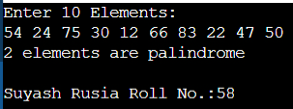

41.Write C program to perform addition of two matrix

#include <stdio.h>

void input(int mat[3][3])

{

    int i, j;

    printf("Enter Matrix Elements:\n");

    for(i = 0; i < 3; i++)

    {

        for(j = 0; j < 3; j++)

            scanf("%d", &mat[i][j]);

    }

}

int main()

{

    int i, j;

    int mat1[3][3], mat2[3][3], mat3[3][3];

    input(mat1);

    input(mat2);

    printf("Sum of Matrix:\n");

    for(i = 0; i < 3; i++)

    {

        for(j = 0; j < 3; j++)

        {

            mat3[i][j] = mat2[i][j] + mat1[i][j];

            printf("%d\t", mat3[i][j]);

        }

        printf("\n");

    }

    printf("\nSuyash Rusia Roll No.:58");

    return 0;

}

Output:

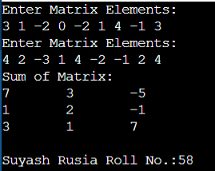

42.Write C program to perform subtraction of two matrix

#include <stdio.h>

void input(int mat[3][3])

{

    int i, j;

    printf("Enter Matrix Elements:\n");

    for(i = 0; i < 3; i++)

    {

        for(j = 0; j < 3; j++)

            scanf("%d", &mat[i][j]);

    }

}

int main()

{

    int i, j;

    int mat1[3][3], mat2[3][3], mat3[3][3];

    input(mat1);

    input(mat2);

    printf("Difference of Matrix:\n");

    for(i = 0; i < 3; i++)

    {

        for(j = 0; j < 3; j++)

        {

            mat3[i][j] = mat2[i][j] - mat1[i][j];

            printf("%d\t", mat3[i][j]);

        }

        printf("\n");

    }

    printf("\nSuyash Rusia Roll No.:58");

    return 0;

}

Output:

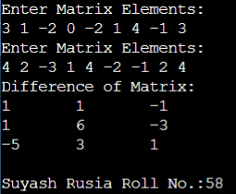

43.Write C program to perform multiplication of two matrix

#include <stdio.h>

void input(int mat[3][3])

{

    int i, j;

    printf("Enter Matrix Elements:\n");

    for(i = 0; i < 3; i++)

    {

        for(j = 0; j < 3; j++)

            scanf("%d", &mat[i][j]);

    }

}

int main()

{

    int i, j, k;

    int mat1[3][3], mat2[3][3];

    int mat3[3][3] = {{0, 0, 0}, {0, 0, 0}, {0, 0, 0}};

    input(mat1);

    input(mat2);

    printf("Product of Matrix:\n");

    for(i = 0; i < 3; i++)

    {

        for(j = 0; j < 3; j++)

        {

            for(k = 0; k < 3; k++)

            {

                mat3[i][j] += mat1[i][k] * mat2[k][j];

            }

            printf("%d\t", mat3[i][j]);

        }

        printf("\n");

    }

    printf("\nSuyash Rusia Roll No.:58");

    return 0;

}

Output:

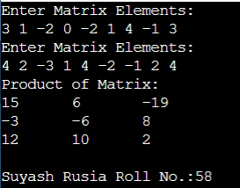

44. Write C program to find transpose of given matrix

#include <stdio.h>

void input(int mat[3][3])

{

    int i, j;

    printf("Enter Matrix Elements:\n");

    for(i = 0; i < 3; i++)

    {

        for(j = 0; j < 3; j++)

            scanf("%d", &mat[i][j]);

    }

}

int main()

{

    int i, j;

    int mat1[3][3], mat2[3][3];

    input(mat1);

    printf("Transpose of Matrix:\n");

    for(i = 0; i < 3; i++)

    {

        for(j = 0; j < 3; j++)

        {

            mat2[i][j] = mat1[j][i];

            printf("%d\t", mat2[i][j]);

        }

        printf("\n");

    }

    printf("\nSuyash Rusia Roll No.:58");

    return 0;

}

Output:

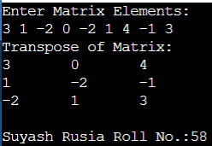

45.Write C program to print the diagonal elements of given matrix

#include <stdio.h>

void input(int mat[3][3])

{

    int i, j;

    printf("Enter Matrix Elements:\n");

    for(i = 0; i < 3; i++)

    {

        for(j = 0; j < 3; j++)

            scanf("%d", &mat[i][j]);

    }

}

int main()

{

    int i, j;

    int mat1[3][3];

    input(mat1);

    printf("Diagonal Elements of Matrix:\n");

    for(i = 0; i < 3; i++)

        printf("%d\n", mat1[i][i]);

    printf("\nSuyash Rusia Roll No.:58");

    return 0;

}

Output:

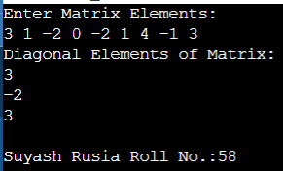

46.Write C program to print lower triangular of given matrix

#include <stdio.h>

void input(int mat[3][3])

{

    int i, j;

    printf("Enter Matrix Elements:\n");

    for(i = 0; i < 3; i++)

    {

        for(j = 0; j < 3; j++)

            scanf("%d", &mat[i][j]);

    }

}

int main()

{

    int i, j, tmp;

    int mat1[3][3];

    input(mat1);

    printf("Lower Triangular Matrix:\n");

    for(i = 0; i < 3; i++)

    {

        for (j = 0; j < 3; j++)

        {

            if(j <= i)

                tmp = mat1[i][j];

            else

                tmp = 0;

            printf("%d\t", tmp);

        }

        printf("\n");

    }

    printf("\nSuyash Rusia Roll No.:58");

    return 0;

}

Output:

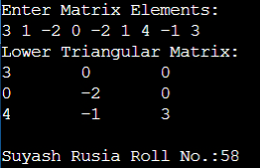

47.Write C program to print Upper triangular of given matrix

#include <stdio.h>

void input(int mat[3][3])

{

    int i, j;

    printf("Enter Matrix Elements:\n");

    for(i = 0; i < 3; i++)

    {

        for(j = 0; j < 3; j++)

            scanf("%d", &mat[i][j]);

    }

}

int main()

{

    int i, j, tmp;

    int mat1[3][3];

    input(mat1);

    printf("Upper Triangular Matrix:\n");

    for(i = 0; i < 3; i++)

    {

        for (j = 0; j < 3; j++)

        {

            if(j >= i)

                tmp = mat1[i][j];

            else

                tmp = 0;

            printf("%d\t", tmp);

        }

        printf("\n");

    }

    printf("\nSuyash Rusia Roll No.:58");

    return 0;

}

Output:

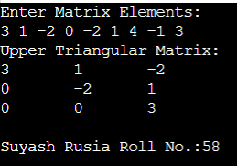

48.Write C program to find frequency of even number in the given matrix

#include <stdio.h>

void input(int mat[3][3])

{

    int i, j;

    printf("Enter Matrix Elements:\n");

    for(i = 0; i < 3; i++)

    {

        for(j = 0; j < 3; j++)

            scanf("%d", &mat[i][j]);

    }

}

int main()

{

    int i, j, even = 0;

    int mat1[3][3];

    input(mat1);

    printf("Number of even elements: ");

    for(i = 0; i < 3; i++)

    {

        for (j = 0; j < 3; j++)

        {

            if(mat1[i][j] % 2 == 0)

                even++;

        }

    }

    printf("%d", even);

    printf("\nSuyash Rusia Roll No.:58");

    return 0;

}

Output:

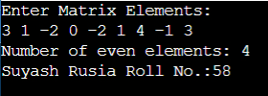

49. Write C program to find frequency of odd number in the given matrix

#include <stdio.h>

void input(int mat[3][3])

{

    int i, j;

    printf("Enter Matrix Elements:\n");

    for(i = 0; i < 3; i++)

    {

        for(j = 0; j < 3; j++)

            scanf("%d", &mat[i][j]);

    }

}

int main()

{

    int i, j, odd = 0;

    int mat1[3][3];

    input(mat1);

    printf("Number of odd elements: ");

    for(i = 0; i < 3; i++)

    {

        for (j = 0; j < 3; j++)

        {

            if(mat1[i][j] % 2 != 0)

                odd++;

        }

    }

    printf("%d", odd);

    printf("\nSuyash Rusia Roll No.:58");

    return 0;

}

Output:

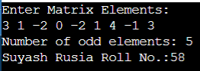

50. Write C program to find the matrix are identical or not.

#include <stdio.h>

void input(int mat[3][3])

{

    int i, j;

    printf("Enter Matrix Elements:\n");

    for(i = 0; i < 3; i++)

    {

        for(j = 0; j < 3; j++)

            scanf("%d", &mat[i][j]);

    }

}

int main()

{

    int i, j;

    int mat1[3][3], mat2[3][3];

    input(mat1);

    input(mat2);

    for(i = 0; i < 3; i++)

    {

        for (j = 0; j < 3; j++)

        {

            if(mat1[i][j] != mat2[i][j])

            {

                printf("The matrix are not Identical");

                return 1;

            }

        }

    }

    printf("The matrix are Identical");

    printf("\nSuyash Rusia Roll No.:58");

    return 0;

}

Output:

